H.T No
Regulations:
A20

Sreenidhi Institute of Science and Technology
(An Autonomous Institution)
Code No: 8EC05 Date: 12-July-2023 (FN)

B.Tech III-Year I- Semester External Examination, July - 2023 (Supplementary)
DATA COMMUNICATION AND COMPUTER NETWORKS (CSE and IT)

Time: 3 Hours Max.Marks:70

Note: a) No additional answer sheets will be provided.
b) All sub-parts of a question must be answered at one place only, otherwise it will not be valued.
c) Missing data can be assumed suitably.
Bloom's Cognitive Levels of Learning (BCLL)

Remember | L1 | Apply | L3 | Evaluate | L5
Understand | L2 | Analyze | L4 | Create | L6

Part - A Max.Marks:20

Answer all QUESTIONS.

 |  | BCLL | CO(s) | Marks
1 | Differentiate between PAN, LAN, MAN and WAN. | L2 | CO1 | [2M]
2 | Define Demultiplexing. | L1 | CO2 | [2M]
3 | List out the functionalities of data link layer. | L1 | CO3 | [2M]
4 | Compare pure ALOHA and slotted ALOHA. | L2 | CO4 | [2M]
5 | Outline the functionality of ARP protocol. | L2 | CO5 | [2M]
6 | Mention the purpose of SMTP protocol. | L1 | CO6 | [2M]
7 | Differentiate between Full-Duplex and Half-Duplex data communication systems. | L2 | CO1 | [2M]
8 | What is subnetting and supernetting? | L1 | CO4 | [2M]
9 | Define Socket address. | L1 | CO6 | [2M]
10 | Define flooding. | L1 | CO5 | [2M]

Part – B Max.Marks:50
ANSWER ANY FIVE QUESTIONS. EACH QUESTION CARRIES 10 MARKS.

 |  |  | BCLL | CO(s) | Marks
11. | a) | Illustrate the working of fiber optic cable with the help of diagram and list out the advantages and disadvantages. | L2 | CO1 | [5M]
 | b) | Discuss the functionalities of different layers in OSI Model with the help of diagrams. | L2 | CO1 | [5M]
12. | a) | Discuss in detail about Digital-to-Analog conversion. | L2 | CO2 | [5M]
 | b) | Illustrate the Analog–to-Analog conversion. | L2 | CO2 | [5M]
13. | a) | Design an algorithm for CRC. Calculate the checksum for given M(x) = 1010001101 and the generator polynomial is g(x) = x^5+x^4+x^2+1 using CRC on both sending side, receiving side. | L3 | CO3 | [5M]
 | b) | Discuss in detail about selective repeat-ARQ protocol with the help of algorithm and diagrams. | L2 | CO3 | [5M]
14. | a) | Explain in detail about IEEE 802.11 protocol. | L2 | CO4 | [5M]
 | b) | Differentiate between CSMA/CD and CSMA/CA. | L2 | CO4 | [5M]
15. | a) | Derive shortest path from node ‘1’ to node ‘7’ for the below graph using Dijkstra’s Algorithm.  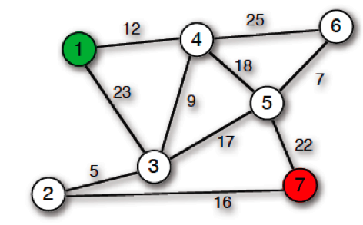 | L3 | CO5 | [5M]
 | b) | Explain in detail about hierarchical routing with the help of neat sketch. | L2 | CO5 | [5M]
16. | a) | Describe Domain Name space with a neat sketch. | L2 | CO6 | [5M]
 | b) | A client transmits data to server using connection orientated protocol. Name the protocol. Explain about protocol connection Termination. | L3 | CO6 | [5M]
17. | a) | List out the advantages and disadvantages of Twisted pair cable. | L1 | CO1 | [4M]
 | b) | Define analog and digital transmission techniques. | L1 | CO2 | [3M]
 | c) | Calculate 7-bit Hamming code word received by a receiver is 1011111. Assuming the even parity, state whether the received word is correct or wrong. If wrong locate the bit in the error? | L3 | CO3 | [3M]
18. | a) | Illustrate the different types of connecting devices. | L3 | CO4 | [4M]
 | b) | Explain in detail about link state routing algorithm. | L2 | CO5 | [3M]
 | c) | Compare TCP and UDP protocols in transport layer. | L2 | CO6 | [3M]

-- 00 -- 00 –

